# Adding protein data to PRIDE database *via* proteome exchange

Before starting - don’t try this on computer where you don’t have admin rights. You need to change settings that you can’t do unless you are admin.

1. Register for a PRIDE account

<http://www.ebi.ac.uk/pride/archive/register>

1. Go here and click download on big blue buttonhttp://www.ebi.ac.uk/pride/help/archive/submission

Extract files and then double click on the .jar file and it should open a screen.

1. Log in using your shiny new user details
2. Choose partial submission (this is because at the time of writing, the MPA does not have a way to export results as a m*z*IDENT file which is required for a complete submission) For most journals, a partial is good enough.
3. Make sure you have the files you need for submission. For a partial submission you will need
   1. The .wiff files received from St andrews (or wherever) -> aka RAW files
   2. Results file – for me this was an excel document for each sample with the id’d peptides and proteins as accessed from MPA via: Export -> csv -> metaproteins (with no of peptides and no of spectra for each included)
   3. Also added PEAK files -> .mgf
4. Fill in the first page
5. Continue with sample ID etc where I put taxonomy for my samples as ‘environmental sample unknown’
6. Choose all files to upload, identify your excel sheets as SEARCH files & click next
7. Choose affliations – ie which SEARCH file is related to which mgf or wiff files
8. Upload files.

If an error comes up about your firewall, then do the following:

**Letting Aspera through firewall**

**1.** Click **Windows Firewall** from **Control Panel > System and Security** then click **Advanced Settings**.

**2.** On the left pane click **Inbound Rules** if you are configuring the server machine, or **Outbound Rules** if you are configuring a client. Note that Aspera transfer servers can act as both server and client. On the right pane select **New rule**.

**3.** Select the **Port** option and click **Next**.

**4.** Choose whether the port is for TCP or UDP and enter the port number or port range. (error from PRIDE said port 22 so I chose TCP and wrote 22 in the box the -> Click **Next**.

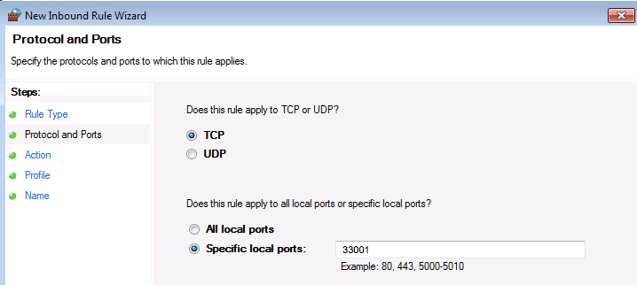

**5.** Choose **Allow the connection**. Click **Next**.

**6.** Choose when to allow the port, based on your computer's network. If you're not sure, leave all options selected. Click **Next**.

**7.** Give the rule an appropriate name (eg Aspera1), then click **Finish**.